Yunlu Li

STAT 5170

Homework 3

Question 1

(a) There is a growing trend with yearly temperature.

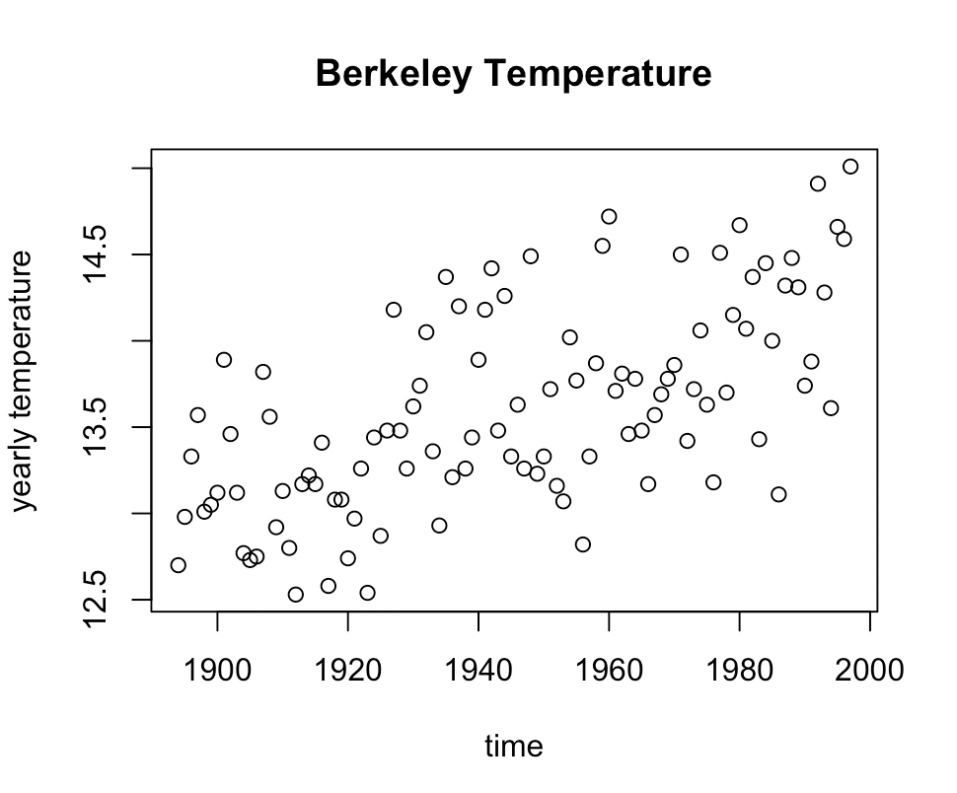

(b) The fit is reasonable. The F-statistic given by summary indicates a strong linear relationship, and diagnostic plots do not show any violation.

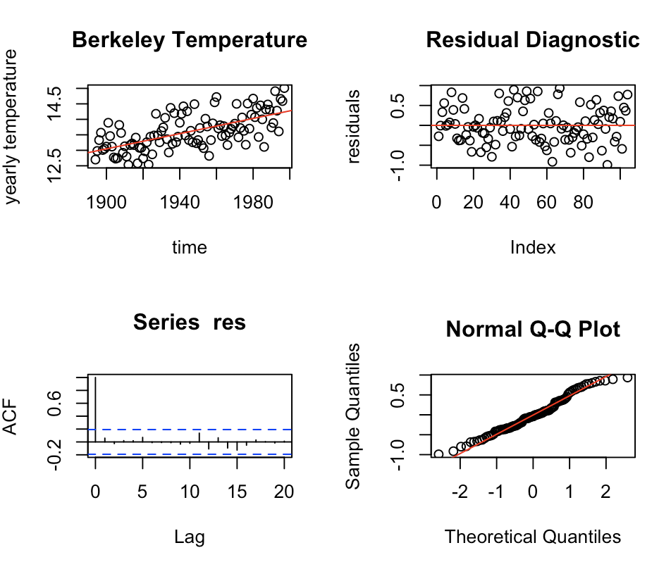

(c) The time series seems not to be stationary because it has an increasing trend. We cannot interpret the ACF plot because the time series is not stationary.

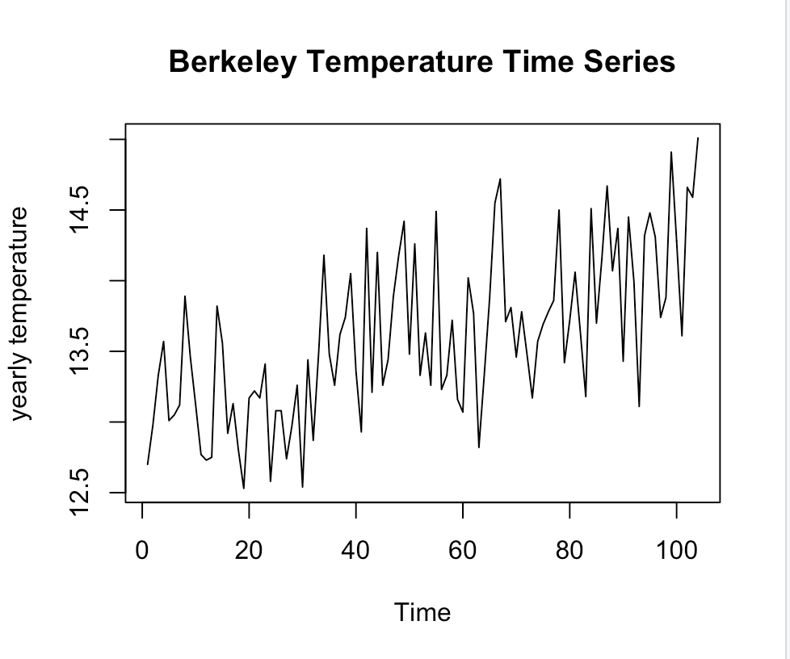 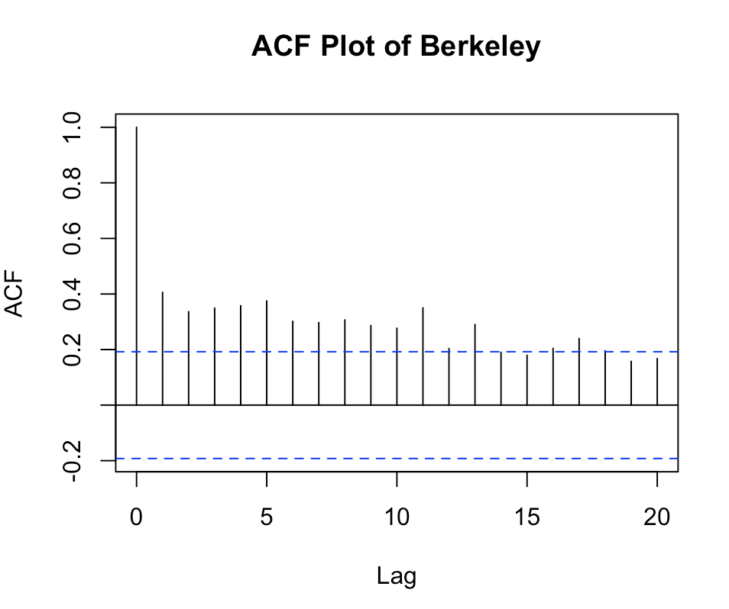

(d) The data seems to be stationary after differencing.

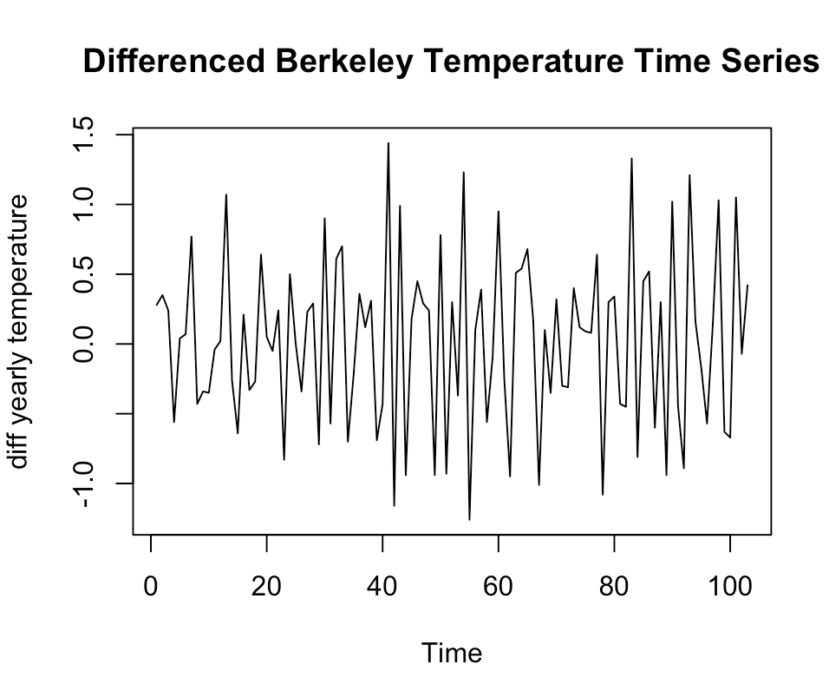 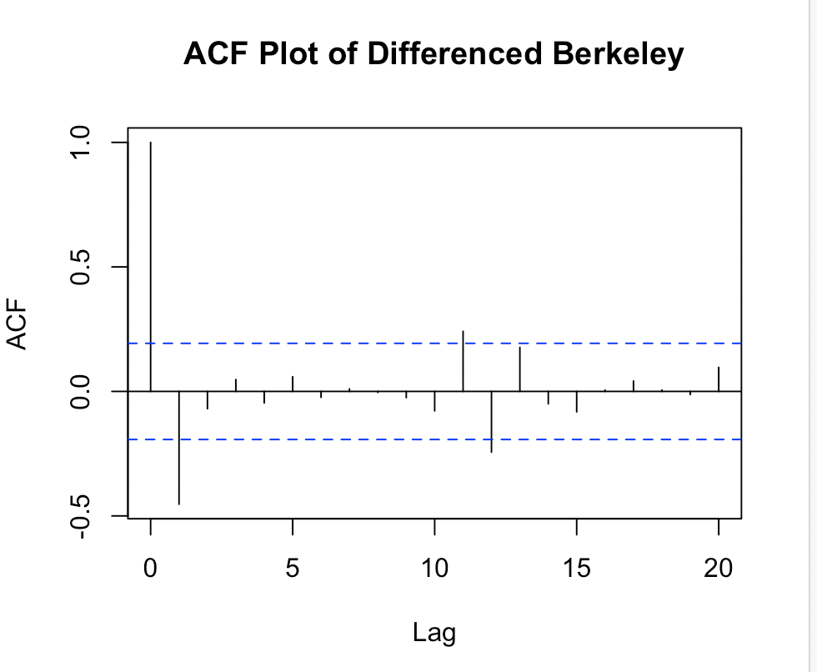

(e) $∇x_{t}=∇β_{1}+∇β_{2}t+{∇w}_{t})=β_{2}+w_{t}-w_{t-1}$. The corresponding model is MA(1) with $β_{2}$ as constant mean and $θ_{1}=-1$. The $θ_{1}$ explains why ACF at lag one is negative and significantly outside the confidence intervals, but the other lags show weak dependency.